**Strawman Data and UX Requirements**

**Planning Permit Project (C3PO)**

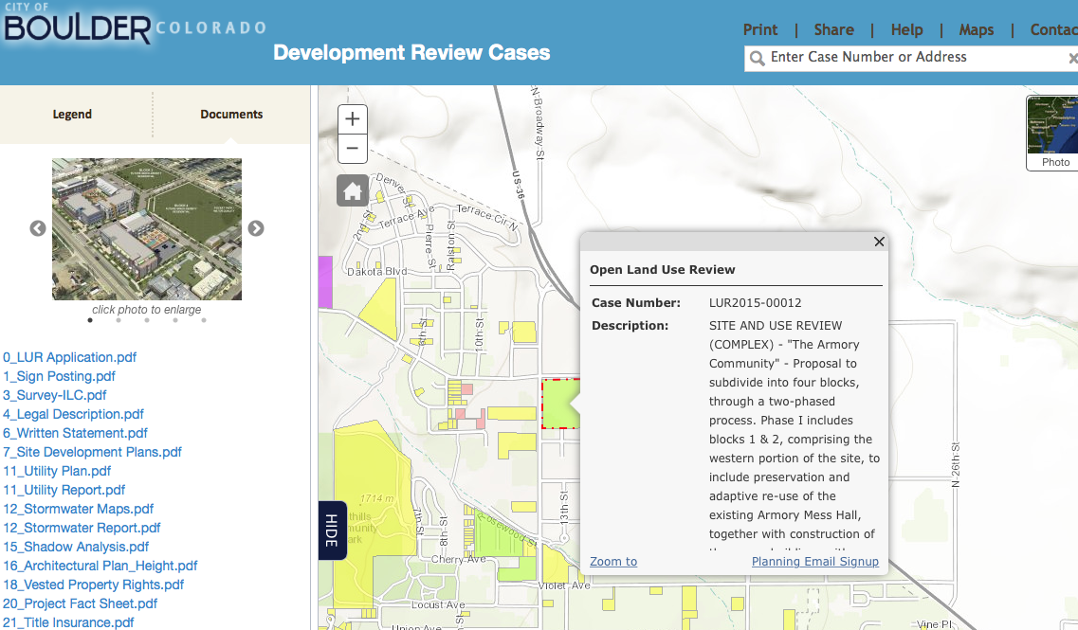

*City Web site for new development projects under consideration.*

*Click on parcel on map –brings up list on the left*

**Annotated *Notes* from Original C3PO Product Requirements**

**General Requirements and Objectives**

Access to Web site in general – ***link is*** ***open to public***.

Access to Direct links to individual documents – ***link is*** ***open to public***.

**User Experience and Design Requirements**

Web site features should be flexible, elements loosely coupled, allow for extensibility and modernization. *Discuss with City*.   
  
Web site updates should be sync’d with City updates in (close-to) real time. *Discuss with City*.

**Technical Requirements - Front End**

Module 1 - Front Page with List of Projects

Application shall contain locative functionality – what development projects are planned or in process connected to the spot where the user is standing and accessing the app. (See Screen Shots below.)

Upon user click, list of candidate projects shall appear; list should be clickable.

For Phase 1, pick first 10 or so projects listed on city web site:

<https://bouldercolorado.gov/plan-develop/development-review-projects>

Plus for single example, Armory Site at 4750 Broadway: <https://www-webapps.bouldercolorado.gov/pds/publicnotice/index.php?caseNumber=LUR2015-00012>

Candidate projects could be presented as list or map (see Yelp approach.)

Click on project will deliver thumbnail description and outline of available information, documents and contacts. ***See proposed strawman organization below.***

Further explore what user should see before they register.  For example, can explore all the data, see what projects are close to you, read comments and such without registering.  ***This means City needs to add schedule, opportunities to comment and direct link to email the Planning Manager. See Strawman***

Application shall contain link to comments on particular development projects.

Module 2 – Create User Profile

If you click the favorites button or keep me informed button, or click to make a comment, you would be prompted to create a user profile.

Enter your user info:  address (for updates on projects near you), mobile number for text notifications; Twitter, Facebook IDs to enable easy sharing of the sites info or comments; also maybe for following updates via tweets or fb posts.

Application shall allow user to set a favorites list of projects in development.

Module 3 - Notifications Module

Application shall contain alerts functions for changes/updates to project documentation pertaining to favorites list.

Would be cool to get the Twitter or FB handle and automatically like our page or handle for them.

***As a community member, I can like a Facebook page to get updates on development projects in boulder. Use Ron Rovtar’s Dakota Ridge page as first implementation.***

***Discuss with City how updates might work***

[***This link***](https://bouldercolorado.gov/newsroom/city-of-boulder-email-lists) ***will get you to the page where you can sign***

***up for news releases and other stuff.***

***Also*** [***this facebook page***](https://www.facebook.com/bouldercolorado.gov?fref=nf) ***is sometimes useful.***

Module 4 – Participation Module

Application shall contain a feature to save/send screen shots, links or documents brought up in the course of a user session.

As a community member, I can follow tweets on development projects in Boulder.

As an engagement system, app can allow posting new development projects to Facebook and Twitter to inform the community of changes, hot topics, and opportunities to comment to decision makers.

* Utilize Citygram code which is open source

Consider more of a push model versus only trying to get people to come to the site and query for info...  And the social media connections seem like a leverage point.  If you Favorite, then you’ll get a newsfeed.

Long term, application should enable user to overlay project on larger subcommunity, on trail and transit systems, and other community-wide elements that often constrain particular planning projects.

App should provide access to schedules, and dynamically inform the user where in the process a particular project is, and at which points public input is possible. Sample steps:

* Concept Plan
* Site Plan Review
  + Site Plan Published
  + First Citizen Comments
  + Staff Response 1, 2, etc.
* Presentation to Planning Board
* Hearing at City Council 1, 2, et al

***See notes below in Strawman***

**Appendix**

**Data Requirements Module**

App should access (and City must commit to) dynamic provision of data as soon as accessible; e.g. not just developer’s original Site Plan, but also updates, staff reviews, Planning Board and City Council comments, public comments, developer town meeting presentations, etc.

The app will interface City data, documents through RESTful web services.

App should provide links to related documentation, for example each project falls with a Subcommunity Plan, which contains guidelines and restrictions that govern projects in that Subcommunity (e.g. Armory part of North Boulder Subcommunity.) All are subject to Boulder Comprehensive Plan.

**STRAWMAN ORGANIZATION AND DESIGN**

**Missing Elements**

Overview of Process

* Phase 1 - Concept Plan
* Phase 2 - Site Plan Review
  + Site Plan Published
  + First Citizen Comments
  + Staff Response 1, 2, etc.
* Phase 3 - Presentation to Planning Board
* Phase 4 – Hearing(s) at City Council 1, 2, etc

Schedule

* should be link/highlight of what stage of the process this project is at.
* Dates for hearings
* Dates for interim deadlines for citizen comments (at least two on this project -

Contacts – at Top of List should be Case Manager email (Currently that contact is in the pop-up window when you click on a parcel.

**Proposed Structure of Documents**

Armory Community Development Project is used below as Example.<http://gisweb.bouldercolorado.gov/agswebsites/pds/development-review/>

**Phase 1 – Concept Plan**

**Phase 2 – Site Plan Review – Initial**

**Documents Submitted - Proposed organization per Ron Rovnar schema**

What – 0. 1. 6. 7. 8. 11. 12. 16. 20. 31. 32. 34.

Where 3. 4. 6.

Legal 18. 21. 24. 29.

**Documents Submitted – Annotated List**

(x.) Numbers from current site – (parentheses contain some suggested descriptive language)

0. Application Form

1. Sign Posting – Digital Equivalent

3. Survey (Topographical Map)

4. Legal Description (of the Site)

6. Written Statement (How This Site Review Proposal Meets the Criteria of the Boulder Comprehensive Plan)

7. Site Development Plan (Map of the Site)

11. Utility Plan (Map of Electric, Sewer)

11. Utility Report (Written Report of Electric, Sewer)

18. Vested Property Rights (???)

20. Project Fact Sheet *Note: a. Overview 142 unites b. Obsolete quickly and not updated; should go first.*

31, 32. Traffic

16. Architectural Plan – *includes Height Note: is this Concept Plan? 112 units (different from 6. Or 20. Above.*

*Missing Numbers – why?*

2015–2-2 Site Review Submittal (Very detailed, non-jargon description)

**Phase 2 – Site Plan Review – Initial**

“Public Notice (2/14/15) (from City – Site Plan is available for comment

* *where do notices happen*
* *how can app get those and send as alerts*

Public Notice 2 (2/21/15)

RR1 Set of Documents - Response to 2/27 City comments (which are not themselves posted)

* Armory Combined Response (Applicant responses, in-line to City comments)
* revised stormwater, utility, architectural plans
* zoning variance request

**Phase 3 - Presentation to Planning Board**

* date, time, location
* opportunity for citizen statements? Format/length?
* do presentations (from city staff or developer) get delivered in advance of meeting?

**Phase 4 – Hearing(s) at City Council 1, 2, etc**

* date, time, location
* opportunity for citizen statements? Format/length?
* do presentations (from city staff or developer) get delivered in advance of meeting?

**Links to Non-City Discussion**

* Armory Developer Web Site
* NextDoor Discussions
* Facebook Discussion

**Glossary Function**

* what is “By right”
* what is “Site Review” as distinguished from “Concept Plan”